Creative Ministries

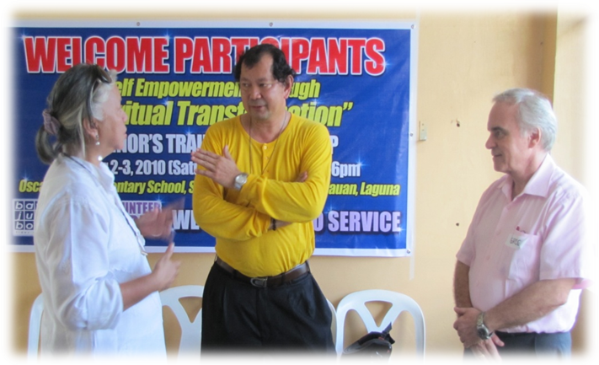
A seminar on Personal Empowerment through Spiritual Transformation organized by Ms. Carmen Prieto (L) and conducted by Canadian Mr. Greg Forbes (R) at the Southville 7 Calauan, Laguna.

By Fr. Pat P. Villasanta, SDB
- A Salesian Priest of Don Bosco and
- a Graduate of the Masters in Social Services and Development
in the Asian Social Institute, Manila (May 2010)

Who is the poor person? Asian Social Institute (ASI) professor William Gois said that, more than being bereft of material blessings, “a poor person is one who has least or no opportunities/ options in life.” Sadly, for a man whose only skill is to drive a tricycle, there is no other option but to become a tricycle driver.

To help people rise above poverty, we need to broaden their horizons. At San Juan Bosco Southville 7 in Calauan, Laguna, this task entails applying St. John Bosco’s paradigm with a dash of 21st century Salesian creativity and at the same time an integration of the ASI’s goal which is ‘to form socially-oriented leaders… to uplift the marginalized sector of the society’.

NEW SALESIAN PRESENCE: Fr Salvador Pablo and I first came to Southville 7 in May 2010. The 107-hectare resettlement area now accommodates over 5,000 poor families from Metro Manila and Cavite, including informal settlers who used to reside along Pasig River.
This National Housing Authority (NHA) project is supported by various private companies and non-government organizations, such as the Diocese of San Pablo, Caritas de Manila, ABS-CBN Foundation, Inc. (AFI), San Miguel Corporation (SMC), Habitat for Humanity, Ayala Foundation and other stakeholders. Their efforts include housing as well as developmental projects to empower residents.
It was the Ayalas who thought of inviting the Salesians of Don Bosco to be involved. Looking at the demographics of Southville 7, it’s not hard to understand why. Based on an AFI survey, 52% of the population is below 18 years old. The largest age group, 22%, is composed of children ages 6 and below. And, with a rate of 10 births a week, they are growing exponentially!
When asked during a rectors’ meeting about our work in Calauan, Fr. Pablo gave a very Salesian response: “Bread, work and heaven. That’s our paradigm.” St. John Bosco’s promise to his children is the very same we hope to give at San Juan Bosco Southville 7, Calauan.

BREAD: Many of the residents are in a state of emergency, and are in dire need of food and proper nutrition. The AFI survey showed that 23% are unemployed and that those with income survive on meager salaries, with majority earning P9,000 and below monthly.
We started getting food and clothing donations from the Salesian and Franciscan communities in Italy, as well as from confreres and friends in the country. Items ranging from rice to rubber slippers have been distributed to the hungry and underprivileged.
Soon to be launched is the Pan de Juan Bosco project, which promises livelihood to bakers and vendors while at the same time offering affordable and nutritious bread enriched with corn.
Clearly, we can’t catechize young people with empty stomachs. But we can sacramentalize and nourish them at the same time. Every time we celebrate Holy Mass with the children, they are given reward points for attending. These points are added up and then exchanged for food and other gifts.

WORK: With only 7% able to find jobs in Calauan, there’s an urgency to help people market their current skills as well as train them to learn more.
Bosconians from Makati came in with a social mapping tool to help us assess the situation further. For example, we learned that residents have specific skills, such as baby-sitting and carpentry, which we can promote to those who require them in Metro Manila, thereby providing them with temp jobs at the least.
To widen their set of skills, friends and volunteers have offered various training sessions such as bread-making, drawing and painting, basic carpentry, vermi-culture and organic farming. Moreover, a number of young people are now taking up technical vocational courses at the Don Bosco Makati and Mandaluyong.

HEAVEN: As we strive to help provide their basic needs, we gradually open them up to experience God through activities ranging from the mundane to the sacred. The Yuppeace Movement and the Brothers from the Theologate Paranaque are one with us in organizing activities such as fun games and sports, bingo sessions, leadership seminars, the Sunday Oratory, the Eucharist and Confession, rosary rallies, and house blessings, residents discover the meaning and value of celebration and presence.
Even movie nights are occasions for fellowship. Three times a night, about 600 of them converge before the Mega Wall (i.e. a side wall of one house that we painted white and use as a movie screen). Armed with an LCD projector and 800-watt speakers, we entertain them with a selection of flicks while they line the street—some sitting, some flat on their backs, others craning their necks just inches from the screen.
Evidently, so much still needs to be done. As we broaden and improve our services, it is clear that, as Fr. Pablo so well put it, “our work here is a non-linear way of ministry.” With the great number of families, we can’t but provide as many options as possible. Indeed, our challenge is toward creative ministry in alleviating poverty through empowering the relocatee-families especially the young in the course of education and value-formation. Through this, we can help the young of Southville 7 tap the great potential they possess as we establish the Salesian Family Spirit and the ASI way of bringing development, growth and meaningfulness in the people’s lives.

